Project Design Phase
Problem – Solution Fit Template

Date | 28 June 2026
Team ID
Project Name | House Rent
Maximum Marks | 2 Marks

Problem – Solution Fit Template:
The Problem–Solution Fit for House Rent – House Rental Management System focuses on identifying the real challenges faced by renters and property owners and providing an effective web-based solution. The platform simplifies the complete house rental process by offering verified property listings, secure user authentication, online property management, booking requests, owner approval, and transparent communication. By addressing these challenges, House Rent ensures a reliable, secure, and user-friendly rental experience for all stakeholders.
Purpose:
- Simplify the house rental process through a centralized online platform.
- Enable renters to search, filter, and book verified rental properties easily.
- Help property owners upload, manage, and approve rental requests efficiently.
- Improve transparency with secure authentication and booking management.
- Reduce manual paperwork and communication delays.
- Provide a responsive and user-friendly interface for renters, owners, and administrators.
Template:
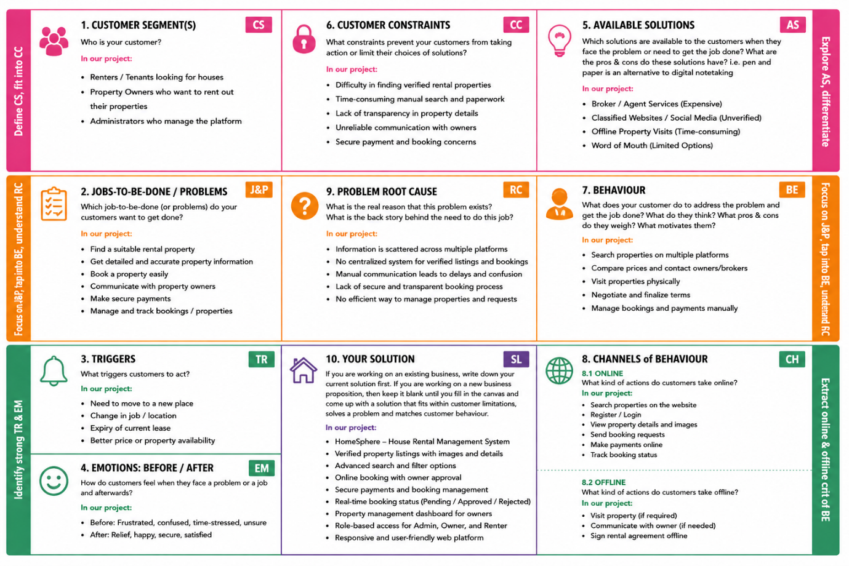

Customer Problem | Current Situation | House Rent Solution | Expected Outcome
Finding genuine rental properties | Renters rely on brokers or unverified online advertisements. | Verified property listings with images, location, and complete details. | Faster and more reliable property search.
Manual booking process | Property bookings require phone calls and paperwork. | Online booking system with owner approval workflow. | Convenient and efficient booking process.
Difficult property management | Owners manually manage property listings and tenant requests. | Owner dashboard for uploading, updating, and managing properties. | Simplified property management.
Lack of secure user access | Unauthorized users may access sensitive information. | Secure role-based authentication for Admin, Owner, and Renter. | Improved data security and controlled access.
Poor communication and booking tracking | Users cannot easily monitor booking requests or approvals. | Real-time booking status (Pending, Approved, Rejected) and transaction history. | Better transparency and user satisfaction.
Time-consuming rental process | Searching and finalizing a rental property takes several days. | Advanced search filters, responsive interface, and centralized platform. | Reduced rental time and improved user experience.

